RPiExtension

For Circuit and Firmware

Version <1.0>

Revision History

|  |  |  |  |
| --- | --- | --- | --- |
| **Date** | **Version** | **Description** | **Author** |
| 24/Oct/21 | 1.0 | Initial system expectations and requirements | Altay Brusan |
|  |  |  |  |
|  |  |  |  |
|  |  |  |  |

Table of Contents

1. Introduction 4

1.1 Purpose 4

1.2 Scope 4

1.3 Definitions, Acronyms, and Abbreviations 4

1.4 References 4

1.5 Overview 4

2. Overall Description 4

3. Specific Requirements 5

3.1 Functionality 5

3.1.1 Single HDMI port 5

3.1.2 Single Network port 5

3.1.3 Two USB ports. 5

3.1.4 MicroSD card. 5

3.1.5 DC power plug. 5

3.2 Usability 6

3.3 Reliability 6

3.4 Performance 6

3.5 Supportability 6

3.6 Design Constraints 6

3.7 On-line User Documentation and Help System Requirements 6

3.8 Purchased Components 7

3.9 Interfaces 7

3.9.1 User Interfaces 7

3.9.2 Hardware Interfaces 7

3.9.3 Software Interfaces 7

3.9.4 Communications Interfaces 7

3.10 Licensing Requirements 7

3.11 Legal, Copyright, and Other Notices 7

3.12 Applicable Standards 7

4. Supporting Information 7

# Introduction

The SRS document captures the complete system requirements for the RPiExt, or a portion of the system. Following is an outline for the project using only natural-language style requirements—with no use-case modeling. It captures all requirements in a single document.

## Purpose

The SRS fully describes the external behavior of the RPiExt. It also describes nonfunctional requirements, design constraints, and other factors necessary to provide a complete and comprehensive description of the requirements for the

## Scope

A brief description of the SyncBox that the **SRS** applies to, the feature or other subsystem grouping, what Use-Case model(s) it is associated with, and anything else that is affected or influenced by this document

## Definitions, Acronyms, and Abbreviations

RPiExt: Rpi Extension card. Raspberry Pi 4 module card.

## References

Board datasheet:

https://datasheets.raspberrypi.com/cm4io/cm4io-datasheet.pdf

## Overview

In the following we will review RpiExt from Functionality, Usability, Reliability, and Performance perspectives.

# Overall Description

The Compute Module 4 IO Board is a companion board for Raspberry Pi Compute Module 4 (supplied separately). It is designed for use both as a development system for Compute Module 4 and as an embedded board integrated into end products.

The IO board is designed to allow you to create systems quickly using off-the-shelf parts such as HATs and PCIe cards, which might include NVMe, SATA, networking, or USB. The major user connectors are located along one side to make enclosures simple

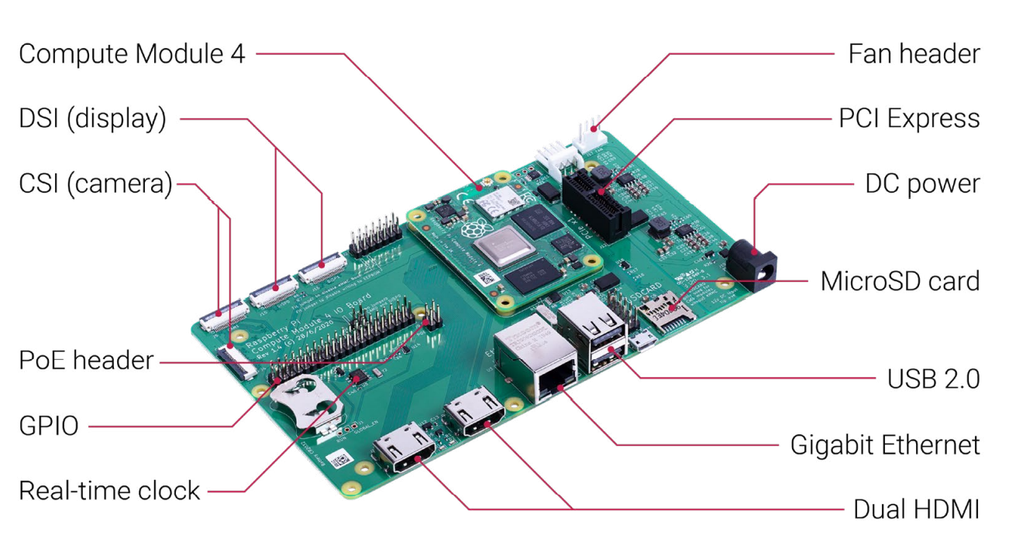

# Specific Requirements

This section of the **SRS** contains all requirements to a level of detail sufficient to enable designers to design a system to satisfy those requirements, and testers to test that the system satisfies those requirements

## Functionality

In this section we will review the required capabilities that are expected from RpiExt.

### Single HDMI port

Provide a HDMI display port.

### Single Network port

Provide a GigE port.

### Two USB ports.

Provide two USB channels.

### MicroSD card.

Provide MicroSD card.

### DC power plug.

Provide 12V input power.

## Usability

The RPiExt is a part of an extended embedded system. Users can mount an operating system through an SD-Card.

## Reliability

Based on experimental examinations the RPExt should be able pass the following criteria:

* Mean Time Between Failures (MTBF): one year
* Availability: 99% of the time
* Mean Time to Repair (MTTR): 1 hours
* Accuracy: 10ns
* Maximum Bugs: 1bug/function
* Bug rate: minor and warnings

## Performance

The performance criteria for RpiExt:

* Response time for a transaction: 250 ns
* Throughput: 1M transaction per second
* Capacity: 1 SD card, 2 USB interface
* Degradation mode: at least 98% stability
* Resource utilization: Rpi4 Module, SD-Card

## Supportability

The project is developed by KiCad 6. The source files are available on GitHub. Issues and feedbacks re provided from community over the GitHub.

## Design Constraints

The physical dimension should be 65x55 mm.

## On-line User Documentation and Help System Requirements

The online documentation is not mandatory, however the design documentations must be shared within the GitHub repository.

## Purchased Components

Rpi4 computer module.

## Interfaces

The interfaces are designed from the radiology technician and technical staff perspectives.

### User Interfaces

NA.

### Hardware Interfaces

USB, GigE, and SD card.

### Software Interfaces

NA.

### Communications Interfaces

Same as hardware interface

## Licensing Requirements

NA.

## Legal, Copyright, and Other Notices

RPiExt follows the Rpi and Rpi 4 IO board license agreements

## Applicable Standards

Same as the Rpi and Rpi IO board requirements.

# Supporting Information

Refer to Rpi and Rpi COM datasheet .